**Contemporary Philippine Arts From the Regions**

**11/12**

**Quarter 2 – Module 1-2**

**Techniques and Performance Practices**

**Contemporary Philippine Arts From the Regions – Grade 11/12**

**Alternative Delivery Mode**

**Quarter 2 – Module 1-2: Techniques and Performance Practices**

**First Edition, 2020**

**Republic Act 8293, section 176** states that: No copyright shall subsist in any work of the Government of the Philippines. However, prior approval of the government agency or office wherein the work is created shall be necessary for exploitation of such work for profit. Such agency or office may, among other things, impose as a condition the payment of royalties.

Borrowed materials (i.e., songs, stories, poems, pictures, photos, brand names, trademarks, etc.) included in this module are owned by their respective copyright holders. Every effort has been exerted to locate and seek permission to use these materials from their respective copyright owners. The publisher and authors do not represent nor claim ownership over them.

Published by the Department of Education, Tagbilaran City Division

Secretary: SDS Joseph Irwin A. Lagura, Ed.D

Undersecretary: ASDS Marcelo K. Palispis, Ed.D.

**Development Team of the Module**

**Writer/s:** Rochelle Margaret C. Real

Faustino Rey T. Hormiguera

Dennis L. Bigcas

**Editors:** Rochelle Margaret C. Real

Faustino Rey T. Hormiguera

Dennis L. Bigcas

**Reviewers:** Mark Vincent Ranay

Alberto A. Lacang

**Management Team:**

SDS Joseph Irwin A. Lagura, Ed.D

Division CID Chief John Ariel A. Lagura, PhD

Division EPS In charge of LRMDS Neolita S. Sarabia, PhD

**Printed in the Philippines by**

**Department of Education – Region VII**

Office Address: Rajah Sikatuna, Dampas District, Tagbilaran City Bohol, Philippines 6300

Telefax: (038)427-1702; (038)427-2506

E-mail Address: [tagbilarancity.division@deped.gov.ph](mailto:tagbilarancity.division@deped.gov.ph);

11/12

Contemporary Philippine Arts From the Regions

**Quarter 2 – Module 1-2**

**Techniques and Performance Practices**

FAIR USE AND CONTENT DISCLAIMER: This SLM (Self Learning Module) is for educational purposes only. Borrowed materials (i.e., songs, stories, poems, pictures, photos, brand names, trademarks, etc.) included in these modules are owned by their respective copyright holders. The publisher and authors do not represent nor claim ownership over them. Sincerest appreciation to those who have made significant contributions to these modules.

# Introductory Message

For the facilitator:

Welcome to the Contemporary Philippine Arts from Regions -11/12 Alternative Delivery Mode (ADM) Module on Techniques and Performance Practices!

This module was collaboratively designed, developed and reviewed by educators both from public and private institutions to assist you, the teacher or facilitator in helping the learners meet the standards set by the K to 12 Curriculum while overcoming their personal, social, and economic constraints in schooling.

This learning resource hopes to engage the learners into guided and independent learning activities at their own pace and time. Furthermore, this also aims to help learners acquire the needed 21st century skills while taking into consideration their needs and circumstances.

In addition to the material in the main text, you will also see this box in the body of the module:



***Notes to the Teacher***

This contains helpful tips or strategies that will help you in guiding the learners.

As a facilitator you are expected to orient the learners on how to use this module. You also need to keep track of the learners' progress while allowing them to manage their own learning. Furthermore, you are expected to encourage and assist the learners as they do the tasks included in the module.

For the learner:

Welcome to the Contemporary Philippine Arts from Region-11/12 Alternative Delivery Mode (ADM) Module on Techniques and Performance Practices!

The hand is one of the most symbolized part of the human body. It is often used to depict skill, action and purpose. Through our hands we may learn, create and accomplish. Hence, the hand in this learning resource signifies that you as a learner is capable and empowered to successfully achieve the relevant competencies and skills at your own pace and time. Your academic success lies in your own hands!

This module was designed to provide you with fun and meaningful opportunities for guided and independent learning at your own pace and time. You will be enabled to process the contents of the learning resource while being an active learner.

This module has the following parts and corresponding icons:

|  |  |  |  |
| --- | --- | --- | --- |
| |  |  | | --- | --- | | C:\Users\DEPED\Desktop\ADM specs\ADM cover and icons\ADM Icons\Alamin2.jpg | ***What I Need to Know*** | | This will give you an idea of the skills or competencies you are expected to learn in the module. |
| |  |  | | --- | --- | | C:\Users\DEPED\Desktop\ADM specs\ADM cover and icons\ADM Icons\What I Know.jpg | ***What I Know*** | | This part includes an activity that aims to check what you already know about the lesson to take. If you get all the answers correct (100%), you may decide to skip this module. |
| |  |  | | --- | --- | | C:\Users\DEPED\Desktop\ADM specs\ADM cover and icons\ADM Icons\Balikan.jpg | ***What’s In*** | | This is a brief drill or review to help you link the current lesson with the previous one. |
| |  |  | | --- | --- | | C:\Users\DEPED\Desktop\ADM specs\ADM cover and icons\ADM Icons\Tuklasin.jpg | ***What’s New*** | | In this portion, the new lesson will be introduced to you in various ways such as a story, a song, a poem, a problem opener, an activity or a situation. |
| |  |  | | --- | --- | | C:\Users\DEPED\Desktop\ADM specs\ADM cover and icons\ADM Icons\suriin.jpg | ***What is It*** | | This section provides a brief discussion of the lesson. This aims to help you discover and understand new concepts and skills. |
| |  |  | | --- | --- | | C:\Users\DEPED\Desktop\ADM specs\ADM cover and icons\ADM Icons\whats more.jpg | ***What’s More*** | | This comprises activities for independent practice to solidify your understanding and skills of the topic. You may check the answers to the exercises using the Answer Key at the end of the module. |
| |  |  | | --- | --- | | C:\Users\DEPED\Desktop\ADM specs\ADM cover and icons\ADM Icons\Isaisip.jpg | ***What I Have Learned*** | | This includes questions or blank sentence/paragraph to be filled in to process what you learned from the lesson. |
| |  |  | | --- | --- | | C:\Users\DEPED\Desktop\ADM specs\ADM cover and icons\ADM Icons\Isagawa.jpg | ***What I Can Do*** | | This section provides an activity which will help you transfer your new knowledge or skill into real life situations or concerns. |
| |  |  | | --- | --- | | C:\Users\DEPED\Desktop\ADM specs\ADM cover and icons\ADM Icons\Tayahin.jpg | ***Assessment*** | | This is a task which aims to evaluate your level of mastery in achieving the learning competency. |
| |  |  | | --- | --- | | C:\Users\DEPED\Desktop\ADM specs\ADM cover and icons\ADM Icons\Additional Activities.jpg | ***Additional Activities*** | | In this portion, another activity will be given to you to enrich your knowledge or skill of the lesson learned. This also tends retention of learned concepts. |
| |  |  | | --- | --- | | C:\Users\DEPED\Desktop\ADM specs\ADM cover and icons\ADM Icons\Answer Key 2.jpg | ***Answer Key*** | | This contains answers to all activities in the module. |

At the end of this module you will also find:

|  |  |
| --- | --- |
| ***References*** | This is a list of all sources used in developing this module. |

The following are some reminders in using this module:

1. Use the module with care. Do not put unnecessary mark/s on any part of the module. Use a separate sheet of paper in answering the exercises.
2. Don’t forget to answer *What I Know* before moving on to the other activities included in the module.
3. Read the instruction carefully before doing each task.
4. Observe honesty and integrity in doing the tasks and checking your answers.
5. Finish the task at hand before proceeding to the next.
6. Return this module to your teacher/facilitator once you are through with it.

If you encounter any difficulty in answering the tasks in this module, do not hesitate to consult your teacher or facilitator. Always bear in mind that you are not alone.

We hope that through this material, you will experience meaningful learning and gain deep understanding of the relevant competencies. You can do it!

|  |  |
| --- | --- |
| C:\Users\DEPED\Desktop\ADM specs\ADM cover and icons\ADM Icons\Alamin2.jpg | ***What I Need to Know*** |

This module was designed and written with you in mind. It is here to help you researches on various contemporary art forms. The scope of this module permits it to be used in many different learning situations. The language used recognizes the diverse vocabulary level of students. The lessons are arranged to follow the standard sequence of the course. But the order in which you read them can be changed to correspond with the textbook you are now using.

Most Essential Learning Competency:

Research on techniques and performance practices applied to contemporary arts.

**CAR11/12ITPP-0c-e-10**

Apply local materials used in creating art.

**CAR11/12ITPP-0c-e-11**

The module is divided into three lessons, namely:

* Lesson 1-2 Techniques and Performance Practices

After going through this module, you are expected to:

* Identify the contemporary art techniques;
* Shows understanding of the materials and techniques
* Appreciate the local materials in varied regions
* Apply the different art techniques in their artworks
* Discriminates among various materials and techniques

|  |  |
| --- | --- |
| C:\Users\DEPED\Desktop\ADM specs\ADM cover and icons\ADM Icons\What I Know.jpg | ***What I Know*** |

Directions: Write **TRUE** on the blank if the statement is true and

**FALSE** if the statement is not true.

\_\_\_\_\_\_\_\_ 1. Digital application comes with augmented reality technology and

transforms Filipino digital artworks into immersive experiences

\_\_\_\_\_\_\_\_ 2. In a large scale art, artists produce works that play with geometric

shapes.

\_\_\_\_\_\_\_\_ 3. .Cubism was the first style of abstract art which evolved at the

beginning of the 20th century in response to a world that was

changing with unprecedented speed.

\_\_\_\_\_\_\_\_ 4. In classical art, the term "found object" is used to describe an object,

found by an artist, which - with minimal modification

\_\_\_\_\_\_\_\_ 5. Social Realism is the realistic depiction in art of contemporary life,

as a means of social or political comment.

\_\_\_\_\_\_\_\_ 6. Minimalism is one of the most important and influential art styles of

the 1970s.

\_\_\_\_\_\_\_\_ 7. Eastern Visayas is the widest abaca supplier.

\_\_\_\_\_\_\_\_ 8. Coir is the fibrous material surrounding the fruit of the coconut tree.

\_\_\_\_\_\_\_\_ 9. Tikog belongs to land grasses.

\_\_\_\_\_\_\_\_ 10. Rattan belongs to the palm family.

|  |  |
| --- | --- |
| C:\Users\DEPED\Desktop\ADM specs\ADM cover and icons\ADM Icons\Balikan.jpg | ***What’s In*** |

Arrange the following words to form a new word.

1. maniadecalco

2. ismcub

3. ismrea laicos

4. lagecol

5. ismminimal

­­

|  |  |
| --- | --- |
| Lesson1 | TECHNIQUES AND PERFORMANCE PRACTICES |

|  |  |
| --- | --- |
| C:\Users\DEPED\Desktop\ADM specs\ADM cover and icons\ADM Icons\suriin.jpg | ***What’s New*** |

***Overview***

A work of art is the skillful manipulation of a medium to express an idea or an experience. For a work of art to be perceived by the senses, it must have a physical manifestation. The **medium** is the substance that is manipulated, while **technique** describes the skillful manipulation of the medium. The technique may utilize tools or technology.

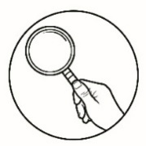***What is It***

There are new techniques that define an art movement. For contemporary arts, the following are a few of these techniques:

## 1. Minimalism

One of the most important and influential art styles of the 1960s, Minimalism identifies works of art most often comprised of geometric shapes in simple arrangements and lacking any decorative or dynamic flourishes. These geometric shapes characterized the elemental or “bare bones” forms of art, which, according to critics, represented the culmination of modern art's progression toward the most simplified form of abstract art possible.

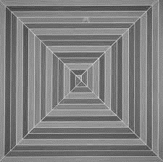It is a movement in various forms or art and design, especially visual art and music, where the work is set out to expose the essence, essentials or identity of a subject through eliminating all non-essential forms, features or concepts. It is characterized by simplicity.

https://www.tate.org.uk/art/art-terms/m/minimalism

## 2. Cubism

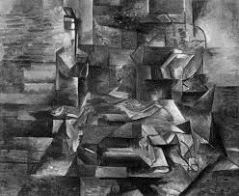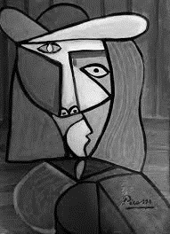Itwas a truly revolutionary style of modern art developed by Pablo Picasso and Georges Braques. It was the first style of abstract art which evolved at the beginning of the 20th century in response to a world that was changing with unprecedented speed. Cubism was an attempt by artists to revitalize the tired traditions of Western art which they believed had run their course. The Cubists challenged conventional forms of representation, such as perspective, which had been the rule since the Renaissance. Their aim was to develop a new way of seeing which reflected the modern age.

Pablo Picasso Cubism Women Spanish Hand Painted Signed

Bottle and Fish by Georges Braques1882-1963

1. **Social Realism**

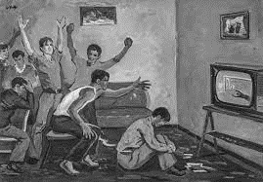It is the realistic depiction in art of contemporary life, as a means of social or political comment.

[Pera Museum's new exhibition explores ...](https://www.google.com/url?sa=i&url=https%3A%2F%2Fwww.dailysabah.com%2Farts%2Freviews%2Fpera-museums-new-exhibition-explores-socialist-realismin-albanian-art&psig=AOvVaw39NxguwyjgJNeQihMILR50&ust=1608088711350000&source=images&cd=vfe&ved=2ahUKEwiZ2sO0g8_tAhUjxosBHZE-DSgQr4kDegUIARDaAQ" \o "Pera Museum's new exhibition explores socialist realism in Albanian art |  Daily Sabah" \t "_blank)

[dailysabah.com](https://www.google.com/url?sa=i&url=https%3A%2F%2Fwww.dailysabah.com%2Farts%2Freviews%2Fpera-museums-new-exhibition-explores-socialist-realismin-albanian-art&psig=AOvVaw39NxguwyjgJNeQihMILR50&ust=1608088711350000&source=images&cd=vfe&ved=2ahUKEwiZ2sO0g8_tAhUjxosBHZE-DSgQr4kDegUIARDaAQ" \o "Pera Museum's new exhibition explores socialist realism in Albanian art |  Daily Sabah" \t "_blank)

**4. Found objects**

They originate from the French ***objet trouve***, describing art created from undisguised, but often modified, objects or products that are not normally considered materials from which art is made, often because they already have a non-art function.

In modern art, the term "found object" is used to describe an object, found by an artist, which - with minimal modification - is then presented as a work of art. The idea is, that the artist believes that the discovered object possesses a certain aesthetic quality - stemming from its appearance, social or personal history - and therefore displays it for the appreciation of others.

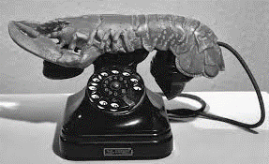 Typical "found objects" include natural materials like sand, earth, stones, shells, curiously shaped pieces of wood, a human skull; or man-made items such as newspaper cuttings, photographs, pieces of glass, fragments of scrap metal, pieces of textile fabric, an unmade bed, a bicycle handlebars, and so on.

artspace.com

1. 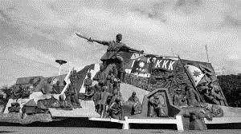**Large scale art** – artists have produced works that play with scale.
2. **Digital application** - It comes with augmented reality technology and transforms

Filipino digital artworks into immersive experiences

Image Source:

https://bit.ly/2MgIjtK

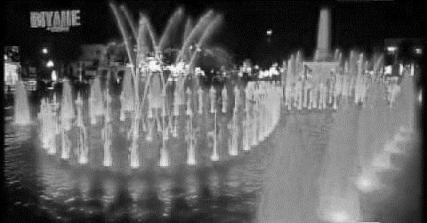

|  |  |
| --- | --- |
| Lesson2 | Local Materials Used in Creating Art |

Local materials in the Philippines are materials that are naturally and locally found in a specific places. Here are some examples:

|  |  |
| --- | --- |
| **MATERIAL** | **PRODUCTS** |
| **Abaca** belongs to Banana family. Its fiber has a natural luster with colors ranging from pure white to ivory and dark brown. Eastern Visayas is the widest abaca supplier. | slippers, ropes, twine, hammock, frame, display jar, jars, Chelsea chair |

|  |  |
| --- | --- |
| **MATERIAL** | **PRODUCTS** |
| **Bakbak** is the outermost covering or leaf sheath of the abaca stalk. It is a flat thick durable sheath as twine or braided. The strong brown fiber is used to make furniture. | mat, bangkuay bin, boxes, bin, display, jar, Cecilia dining table, and arm chair |

|  |  |
| --- | --- |
| **MATERIAL** | **PRODUCTS** |
| **Bamboo** is a raw material used in creating many products. It is used in construction, textile, musical instruments, weapons, and many more. It is abundant in La Union, Pampanga,  Capiz, Cebu and Bukidnon | kubing, bungkaka, tongatong, angklung, pateteg, gabbang |

|  |  |
| --- | --- |
| **MATERIAL** | **PRODUCTS** |
| **Buntal** is a cylindrically shaped fiber.  The supple ivory white strands are quite durable, pliable, and have good dyeing qualities. The most noted producers are the provinces of Bohol, Pangasinan, Marinduque and Quezon. | bags, shoes, desk accessories like pen holder, picture frames, file trays, wallets, place mats, braide, lampshades, window blinds |

|  |  |
| --- | --- |
| **MATERIAL** | **PRODUCTS** |
| **Buri** is extracted from the matured leaves of the buri palm. The fiber is durable and resistant to moisture. . | hats, bags, baskets, memorabilia boxes, perfume tray, & other woven products |

|  |  |
| --- | --- |
| **MATERIAL** | **PRODUCTS** |
| **Coir** is the fibrous material surrounding the fruit of the coconut tree which are abundant in CALABARZON, Northern  Mindanao and Davao Region | indoor or outdoor fiber carpets, wall covering, doormat, trellises, and geo textiles |

|  |  |
| --- | --- |
| **MATERIAL** | **PRODUCTS** |
| **Nito** is a plant belonging to the fern family that grows abundantly in the hinterlands of Mindanao. abundantly in the hinterlands of Mindanao in  Southern Philippines. | bags, bread tray, lampshade and decorative jar |

|  |  |
| --- | --- |
| **MATERIALS** | **PRODUCTS** |
| **Pandan** is a tropical plant. It is processed and transformed into splints that are being used as raw material which are abundant in Calatrava in the Visayas. | baskets, hats, picture frames and bags |

|  |  |
| --- | --- |
| **MATERIALS** | **PRODUCTS** |
| **Rattan** belongs to the palm family. There are different types of rattan palms, such as high or low climbers, single stemmed or clustered rattan species. | baskets, picture frames, furniture and other novelty items, Zoya lounge chair, Valencia queen size bed, Rest divan. |

|  |  |
| --- | --- |
| **MATERIALS** | **PRODUCTS** |
| **Tikog** belongs to sea grasses. It is a native reed plant used as a raw material for mat weaving. | bags, decorative mats, hampers, newspaper racks, table mat, waste bin, tower candle holder, wall décor. |

## Different Contemporary Art Techniques and Performance Practices

1. 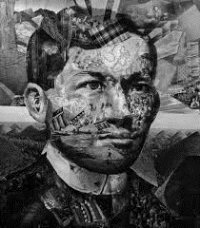**Collage** – Is made by adhering flat elements such as newspaper or magazine cut-outs, printed text, illustrations, photographs, cloth, string, etc. to a flat surface to create a thick layer that is almost like a relief sculpture.

1. 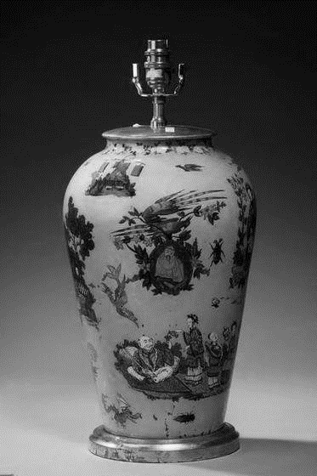**Decalcomania** – Is the process of applying gouache to paper or glass then transferring a reversal of that image on to canvas or other flat materials.

Image source: https://bit.ly/2FBjyrN

1. 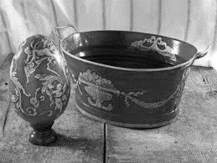**Decoupage** – Is done by adhering cut-outs of paper and then coating these with one or more coats of transparent coating varnish.

*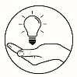* ***What I Have Learned***

**LET’S RECYCLE!**

Directions: Using used newspaper or magazine cut-outs, cloth, strings or whatever available materials you have, produce a collage, a decalcomania or a decoupage. Choose only one among the three techniques using the following criteria:

Creativity - 20 points

Design - 20 points

|  |  |  |
| --- | --- | --- |
|  |  |  |
| Craftsmanship | - | 10 points |
| Total | - | 50 points |

|  |  |
| --- | --- |
| C:\Users\DEPED\Desktop\ADM specs\ADM cover and icons\ADM Icons\Isagawa.jpg | ***What I Can Do*** |

**LET’S GET TO KNOW YOUR LOCAL ARTIST!**

Directions: Applying the knowledge you have learned from the lessons in this module, fill out the boxes below.

|  |  |  |  |
| --- | --- | --- | --- |
| Local Artist | Artform | Materials used | Techniques used |
|  |  |  |  |
|  |  |  |  |
|  |  |  |  |
|  |  |  |  |
|  |  |  |  |

|  |  |
| --- | --- |
| C:\Users\DEPED\Desktop\ADM specs\ADM cover and icons\ADM Icons\Tayahin.jpg | ***Assessment*** |

Directions: Choose the best answer. Write the letter of your choice on the blank provided.

\_\_\_\_\_\_ 1. It Is done by adhering cut-outs of paper and then coating these with

one or more coats or transparent coating of varnish.

1. Decoupage C. Assemblage
2. Decalcomania D. Collage

\_\_\_\_\_\_ 2. It Is made by adhering flat elements such as newspaper or magazine

cut- outs, printed text, illustrations, photographs, cloth and string.

1. Assemblage C. Decalcomania
2. Collage D. Decoupage

\_\_\_\_\_\_ 3. It is the process of applying gouache to paper or glass then

transferring a reversal of that image on to canvas or other flat

materials.

1. Assemblage C. Decalcomania
2. Collage D. Decoupage

\_\_\_\_\_\_ 4. It is one of the most important and influential art styles of the 1960s

which identifies works of art most often comprised of geometric

shapes in simple arrangements.

A. Cubism C. Social realism

B. Minimalism D. Large-Scale Art

\_\_\_\_\_\_ 5. Juan Luna’s Spoliarium displayed in the National Museum is an example

of \_\_\_\_\_\_\_.

A. Cubism C. Social realism

B. Minimalism D. Large-Scale Art

\_\_\_\_\_\_\_ 6, It is an attempt by artists to revitalize the tired traditions of

Western art which they believed had run their course.

1. Cubism C. Social realism
2. Minimalism D. Large Scale Art

\_\_\_\_\_\_ 7. It is the realistic depiction in art of contemporary life, as a means of

social or political comment.

A. Cubism C. Social Realism B. Minimalism D. Large-Scale Art

\_\_\_\_\_\_ 8. This place is the widest abaca supplier.

1. Southern Visayas C. Northern Mindanao
2. Eastern Visayas D. Southern Mindanao

\_\_\_\_\_\_ 9. It comes with augmented reality technology and transforms Filipino

digital artworks into immersive experiences

A. Digital application C.Social Realism

B. Minimalism D. Large Scale Art

\_\_\_\_\_\_ 10. This is the place where Buntal is abundant.

1. Cebu C. Bataan
2. Batangas D. Bohol

***References:***

Sining Rehiyon Contemporary Philippine Art in the Regions pp. 111-159

For Senior High School

Published by C & E Publishing, Inc.

839 EDSA, South Triangle, Quezon City

Copyright @ 2018 by C & E Publishing, Inc., Gerald Lico, Glecy Cruz Atienza, Imelda Cajipe Endays, Jason Pilapil Jacobo, and Ramon P. Santos

Datulin, Flaudette May, Roberto Paulino, Aileen Legaspi-Ramirez and Louise Marcelino, ***Contemporary Philippine Arts from the Regions***: First ed. Manila,

Philippines: Rex Bookstore, 2016.

Ganzon, Carlo Luis C., ***Journey: Contemporary Arts of the Philippines***. Phoenix Publishing House Inc., Quezon City, Philippines, 2017.

Perez, Angelita Benavides, ***Philippine Contemporary Arts: Expressions and Experimentation.*** Brilliant Creations Publishing, Inc.,Quezon City, Philippines, 2016.

***https://openclipart.org/detail/295772/arts-are-at-the-heart-of-smart*** https://www.tate.org.uk/art/art-terms/m/minimalism https://psa.gov.ph/non-food/coconut

http://www.visual-arts-cork.com/definitions/found-objects.htm ***https://www.google.com.ph:spoliarium, 2020***

https://bit.ly/2MgIjtK

https://bit.ly/2FBjyN

**For Inquiries or feedback, please write or call:**

Department of Education – Bureau of Learning Resources (DepEd-BLR)

DepEd Tagbilaran City Schools Division

Rajah Sikatuna, Dampas, Tagbilaran City

Telephone: 038)427-1702; (038)427-2506

E-mail Address: dtagbilarandivision@yahoo.com